# M1C2 UI/UX Assignment

*During this module, you have been introduced to UI/UX Development. UI/UX is used to make sure that applications are accessible and easily understood. You have been introduced to a variety of tools like sitemaps, wireframes, and color schemes, that help developers when they are working on user interfaces and user experiences. You will use a variety of those tools during this assignment. If you can’t remember how to build what is asked, refer back to the videos that explain each concept and try looking up examples. Please complete the following assignment and reach out on the Support App to have a mentor review your work. If you have any questions or need any help, please reach out so we can help you! This assignment must be completed to pass this section of the coursework.*

**Task One:** Referencing this image, create a low-fidelity wireframe.

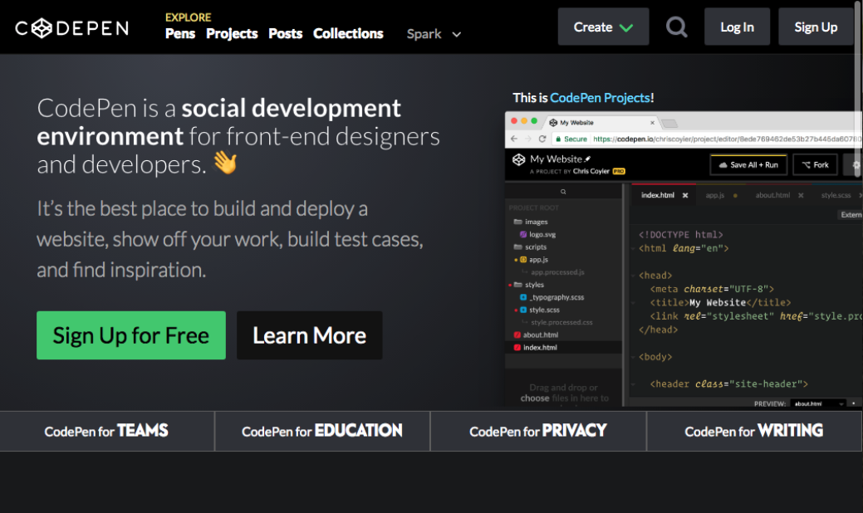

**Task Two:** Use one of the following websites and the inspect tool to identify 2-3 colors used repeatedly as part of the site’s color scheme. Remember that different shades of gray and black can be included as a color.

* <https://timmyomahony.com/> rbg(240 240 232) rbg(114 100 92) rbg(0 0 0)
* <https://sebkay.com/> #888 #ddd #5e5e5e
* <https://jonny.me/> not working
* <https://jacekjeznach.com/> Not working

**Task Three:** Create a user story by referencing one of these websites

* Twitter <https://twitter.com/home?lang=en>
* Youtube <https://www.youtube.com/>
* Facebook <https://www.facebook.com/>
* Google <https://www.google.com/>

Twitter:

**Task Four:** Identify the prime objective of Facebook, Twitter, Google, and Youtube.

Facebook: To connect users and allow them to communicate with each other.

Twitter: for users to connect and express their thoughts.

Google: organize Internet information in a way users can search for it.

Youtube: For users to share videos they create and see videos of other creators.